Micah Bruning

10 Dec. 2021

247 Cherry Street, New York, New York

*Project Overview*

Some of New York’s largest property developers – JDS Development Group, L+M Development Partners, CIM Group, and Starrett Development – are planning to erect four new luxury apartment towers in Manhattan’s Two Bridges neighborhood. Located right along the lower Manhattan waterfront, the three towers are set to provide 2,775 rental units with approximately 700 devoted to affordable housing. The four towers are split among three separate projects – one 1,008-foot-tall skyscraper at 247 Cherry St., a pair of 800-foot-tall towers at 260 South St., and a 700-foot-tall tower at 259 Clinton St. (*Figure 1*).[1]

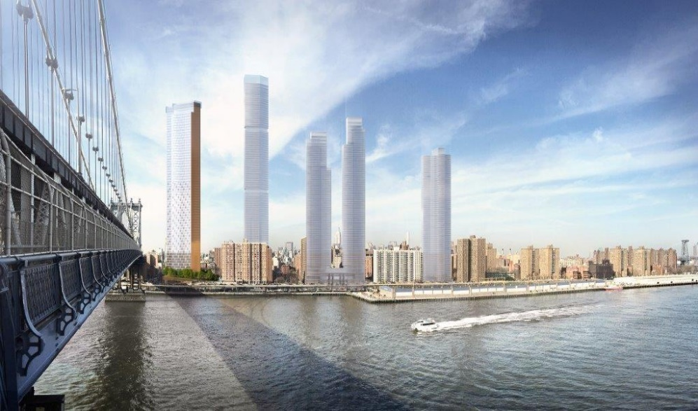

Figure : The Four Proposed Towers Next to the Existing "One Manhattan Square" Tower (Source: ShoP Architects)

Because each of the towers have their own distinct proposals, focusing on the largest tower at 247 Cherry St. is the most productive because it’s the most controversial of the three.

Zoning, Land Use and City Plans

247 Cherry St. is in a C6-4 zoned lot. Commercial zoning districts in New York City have residential equivalents that dictate their bulk regulations. C6-4’s residential equivalent is an R10 zone, the largest residential zoning by height and floor area ratio in New York.[2] More pertinent than the dictated zoning of the lot, 247 Cherry St. is a part of the Two Bridges Large Scale Residential Development (LSRD) area. Large Scale Development (LSD) areas in New York permit more lenient development standards which encourage larger-scale projects that would otherwise have to be achieved through rezoning.

The tower at Cherry St. is immense in scale, but most of the planned aspects of the development don’t require a lot of modifications to the LSRD. The developers applied to build their tower on parcels 4A and 4B (*Figure 2*), so they sought approval from the Commission to combine the two.

Figure -- Development Site of the Four Towers (Source: 247 Cherry St. Land Use Application)

Because of its position in an LSRD, parcel 4A was already approved by the city to be developed “without regard for height and setback regulations” in 1985. Similarly, in 1995, parcel 4B was approved to be developed with more lenient height requirements and a reduction in minimum spacing requirements between its building and the two in parcel 4A. Both parcels still have restrictions on the total square footage available for residential and commercial use, though. Although most of the building will reside in parcel 4A, by combing the two parcels the developers gain more available residential and commercial square footage. Between the two parcels there is roughly 300,000 sf. permitted for residential usage. The developers were hoping to increase that number to almost 800,000 sf.

Currently, parcel 4A consists of a 10-story senior home and a one-story commercial building (*Figure 3*). Parcel 4B has a 21-story affordable housing development. The tower would sit in parcel 4A with a portion of it hanging over the 10-story senior home (*Figure 4*). Ten units from the senior home would be relocated into the new tower as well.

Figure 3 – 10-Story Senior Home at Parcel 4B (Source: Google Maps Street View)

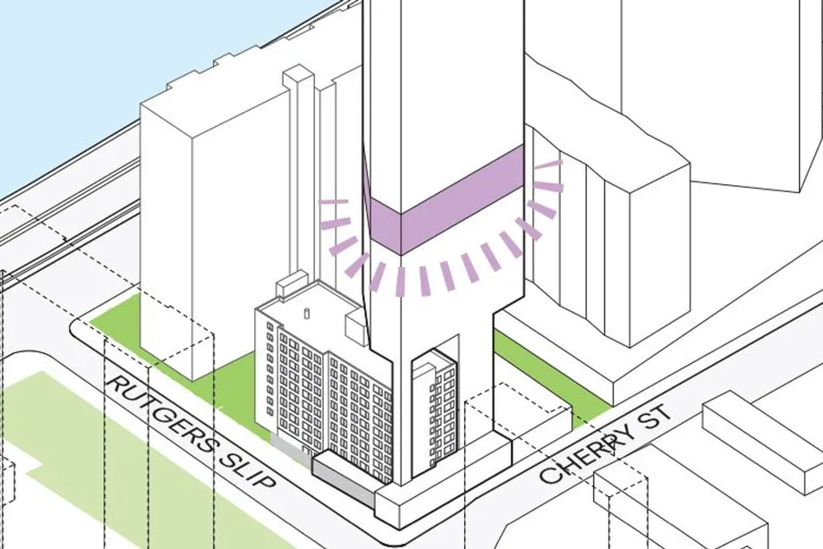

Figure -- Cherry St. Tower Between and Over Two Buildings in Parcel 4A (Source: City Realty)

There would be roughly 5,000 sf. of newly developed community space, and 3,000 sf. of upgraded retail space (*Figure 5*).[3]

Figure -- View from Cherry St. with Senior Home as the Rightmost Building (Source: ShoP Architects)

Although it’s surprising that a tower this large could be placed near buildings that are significantly shorter, the Commission understandably approved the project because the parcels were already developed without regard to height or spacing requirements. The increase in available square footage for residential use is huge, but the purpose of the LSRD is to create lax development standards so it makes sense that the increase was okayed. The project’s underlying C6-4 zoning becomes nearly irrelevant because the Commission can allow the developers to build with no regards to the major regulations that the Zoning Resolution sets. The flexibility of an LSD, originally intended to facilitate the construction of massive social housing projects following the Great Depression, is being used to construct a jarringly disruptive luxury housing complex.[4] An LSRD shouldn’t be there if its existence only exacerbates negative development trends, but the ship to modify it had set sail by the time the developers filed an application.

New York City has no comprehensive plan. There is currently, however, a comprehensive waterfront plan which outlines goals unique to the city’s waterfront communities. Chief among those goals is the development of infrastructure to manage the increased risk of flooding.[5] If anything, the Cherry St. tower will aid in this goal because the developers are panning major improvements to the flooding infrastructure near the tower and adjacent housing complexes. The draft for the new waterfront plan does emphasize a need for mixed-income housing, which Cherry St. will partially deliver. Twenty-five percent of the units will be considered affordable, but most 1-bedroom apartments will likely be at least $4,500 – based on the rent from the nearby One-Manhattan Square.[6]

Opposition to this project had little grounds to rest their case on. Their best bet at stopping or modifying its construction would have been through a Uniform Land Use Review Procedure (ULURP). New developments within an LSD must undergo the city’s ULURP process before being approved if the development is deemed to be a significant enough change. The ULURP process creates a restrictive declaration – a binding agreement that the proposed modification will be strictly adhered to – which makes it easier for surrounding communities to receive promised benefits associated with new developments.[7] It also permits city council to completely deny the project. Mayor DeBlasio would likely veto this decision, but there would be a possibility to overturn this veto with enough votes.

*Legal History*

Unsurprisingly, erecting four glass monoliths over the public housing projects of lower Manhattan has led to several lawsuits and widespread community backlash. In December of 2018, the City Planning Commission (CPC) approved the Cherry St. developer’s “minor modification” to the Two Bridges LSRD allowing for the creation of their 80-story building. Prior to the approval, the developers held four voluntary public hearings in which local residents voiced their concerns over the building’s inconsistency with the neighborhood’s context, the loss of open space and sunlight and the underwhelming number of units devoted to affordable housing.[8] The central contention against the development, however, was its classification as a “minor modification” to the LSRD. This classification enabled the developer and the Commission to completely skip the ULURP process.

From an outside perspective, it’s surprising that the Commission used this classification. No reasonable person would consider the project a minor change to the existing landscape, and while Manhattan is already proliferated with skyscrapers, Two Bridges and the Lower East Side in general have a much shorter average building height than the new tower. With One-Manhattan Square, the leftmost building in Figure 1, already disrupting the area’s built aesthetics, the 247 Cherry St. project would continue to dramatically change the fabric of Two Bridges. Yet the planning Commission provided a semi-convincing justification for this designation. During the December meeting, Commission chair Marisa Lago argued that, while the project isn’t minor in scale, they’re considered minor modifications because the previous parcels had already been approved to be developed with incredibly permissive standards. The Commission did, however, falsely claim that the new tower wouldn’t be out of context because of One-Manhattan Square’s nearby presence.[9] One other large tower in a sea of mid-rise buildings doesn’t provide ample context, and two wrongs don’t make right.

The public backlash materialized into three separate lawsuits seeking to nullify the Commission’s decision. The most relevant lawsuit, and the one that ultimately stalled its development, was filed by City Council and the Manhattan Borough President Gale Brewer on the grounds that the project couldn’t be considered a “minor modification” to the LSRD. The suit’s primary purpose was to change the project’s classification so that it would undergo the ULURP process and hopefully reap more community benefits or be turned down by City Council.[10]

In August of 2019, State Supreme Court Justice Arthur Engoron ultimately sided with the plaintiffs, claiming that the project could not be considered minor and must undergo the ULURP process. Engoron’s ruling seems reasonable and sane, but not legally accurate. Engoron stated that “you can’t just do this because the zoning allows it. I just can’t believe this is the case.”[11] What’s funny is that Erongan called the “minor modification” label Orwellian, when what’s truly Orwellian is a judge saying you can’t do something solely because it’s legal. City Council was incredibly happy with the ruling. The ULURP process enables them to drastically change and even deny a project if both the Manhattan Borough President and the Community Board make recommendations against its approval – a likely outcome as these two groups were involved in the initial lawsuit. Both Mayor De Blasio, trying to fulfill affordable housing promises he made, and the Commission were frustrated by the ruling, firm in their belief that Erongan made the wrong call.[12]

Fast forward a year and one of the state’s intermediate appellate courts unanimously overturn Erongan’s decision, citing that they found “no error in the CPC’s determination that the project… was not subject to the Uniform Land Use Review Procedure.” The city’s Zoning Resolution, the court stated, gives the Commission ultimate say in what should be determined a minor modification to an LSRD.[13] This decision didn’t immediately give the project the green-light, though. Two other lawsuits – one dealing with environmental review and one with more minor zoning issues – also got the approval of Ernogan in February of 2020. Yet both suits faced the same fate as the first one and got unanimously overruled by the intermediate appellate courts a year later. Because the intermediate appellate courts were unanimous in all three of their decisions, the only hope for the plaintiffs of the three suits was to appeal to the higher court of appeals, which declined their request.[14]

By the spring of 2021, the developers all had legal approval to construct their towers. Unfortunately, the Commission’s initial approval of the project and the intermediate courts interpretation of the ULURP procedures are entirely sound. The Commission should have a final say in what’s determined to be a minor modification, and in the case of these towers it appears that they are in line with the rules set out by the LSRD. Despite a legally justifiable outcome, the projects will still negatively impact the area.

*Interview*

I spoke with Marc Richardson, Vice President of the Tenants United Fighting for Lower East Side (TUFF-LES). TUFF-LES was one of several community groups that filed a lawsuit that claimed the project didn’t conduct an adequate environmental review process. Marc had an incredibly matter-of fact tone. He said that, from the very beginning, he knew the legal battle against the developers would be lost. He seemed more hopeful in the lawsuit filed by the Borough President than the lawsuit TUFF-LES filed. The ULURP process, Richardson said, could have ideally allowed for more than just lip-service from the developers and given the community more sway in how the tower would be built. He didn’t seem optimistic that a ULURP would have completely stopped the project, though. He noted that the councilwomen representing Two Bridges, Margaret Chin, made promises to stop its development if ULURP could be achieved, but he was doubtful that she could rally enough Council votes to overturn DeBlasio’s inevitable veto of the Council’s decision.

Marc lives right next door to the future 247 Cherry St. tower. His main concern was the loss of open space and sunlight. He also mentioned concerns with construction and how that will impact his own parking. He said the new towers will set a precedent for what developers could do in the area. While he noted that developers can afford stronger legal teams than the local community organizations, he still seemed encouraged by the fact that a judge sided with their lawsuit in the first place. Marc emphasized that he’s been in the area for a while, so he’s accustomed to the fact that it’s constantly changing.[15]

*Conclusion*

Luxury apartments moving into a lower-income community is nothing new in American cities. The apartment complex at 946 Westminster St., for instance, sparked similar conversations about displacement, design inconsistencies and how the project was designated. The towers being built in Two Bridges are the epitome of this dynamic, though, and represent its most extreme form. Not only are the towers being placed in a low-income neighborhood, but they’re also going to be right next to some of the country’s few public housing projects. Most new apartment buildings tend to change a neighborhood’s existing character, but they can at least spur more investment into an area and lead to an overall cosmetic improvement. These towers, however, are so glaringly out of place that they’re guaranteed to create an incoherent aesthetic environment. Finally, these towers aren’t just taking space from the community, they’re directly taking sunlight from poor children (*Figure 6*).

Figure -- Projected Shadow Impact of Towers (Source: MASNYC.org)

References

“December 5th, 2018: City Planning Commission Public Hearing.” *Youtube.com*. 10 Dec. 2018. <https://www.youtube.com/watch?v=LEDaDixea5Q>.

Elizabeth Kim, et al. “Judge Grants Temporary Halt on Two Bridges Mega Development after Hearing Three Lawsuits.” *Gothamist*, Gothamist.com, 6 June 2019, https://gothamist.com/news/judge-grants-temporary-halt-on-two-bridges-mega-development-after-hearing-three-lawsuits.

Larsen, Keith. “Two Bridges Towers Get Green Light from NY Court of Appeals.” *The Real Deal New York*, The Real Deal New York, 27 May 2021, <https://therealdeal.com/2021/05/27/two-bridges-project-opponents-lose-final-appeal/>.

“Land Use Review Application: 247 Cherry St.” *City Planning Commission*. 21 Mar. 2017. https://www1.nyc.gov/html/mancb3/downloads/cb3docs/247%20Cherry%20Street%20-%20Electronic%20Filing.pdf

“LSDs: Better Site Planning or a Bad Trip?” *The Municipal Art Society of New York*, <https://www.mas.org/news/lsds-better-site-planning-or-a-bad-trip/>.

M 180507(C) ZSM. *City Planning Commission*. 5 Dec. 2018. https://www1.nyc.gov/assets/planning/download/pdf/about/cpc/180507c.pdf

“One Manhattan Square at 252 South St. in Two Bridges.” *StreetEasy*, https://streeteasy.com/building/one-manhattan-square.

Richardson, Marc. Phone Interview. 6 Dec. 2021.

“Shadow Analysis for the Two Bridges LSRD Proposals.” *The Municipal Art Society of New York*, The Municipal Art Society of New York, https://www.mas.org/interactive_features/two-bridges-shadow-analysis/.

Shop Architects. “Cherry Street.” *JDS Development Group*, https://jdsdevelopment.com/portfolio/cherry-street.

Spivack, Caroline. “Inside the Legal Fight for Two Bridges Towers.” *Curbed NY*, Curbed NY, 7 June 2019, <https://ny.curbed.com/2019/6/7/18654096/nyc-two-bridges-towers-legal-fight-lawsuits-court>.

*Supreme Court, Appellate Division*. 27 Aug. 2020. https://www.nycourts.gov/courts/AD1/calendar/appsmots/2020/August/2020_08_27_dec.pdf

Young, Michael. “JDS Development's Supertall 247 Cherry Street Gets Green Light after City Planning Approval on the Lower East Side.” *New York YIMBY*, New York YIMBY, 21 Dec. 2018, https://newyorkyimby.com/2018/12/247-cherry-streets-future-gets-green-light-after-city-planning-approval.html.

*Zoning Resolution: The City of New York*, City Planning Commission, Dept. of City Planning, 2011.

1. Young, Michael. “JDS Development's Supertall 247 Cherry Street Gets Green Light
2. *Zoning Resolution*. Section 15-20
3. “Land Use Review Application: 247 Cherry St.” *City Planning Commission*.
4. “LSDs: Better Site Planning or a Bad Trip?”
5. *NYC Draft Comprehensive Waterfront Plan.*
6. “One Manhattan Square at 252 South St. in Two Bridges.” StreetEasy
7. “LSDs: Better Site Planning or a Bad Trip?”
8. M 180507(C) ZSM. *City Planning Commission.*
9. “December 5th, 2018: City Planning Commission Public Hearing.” *Youtube.com*.
10. Spivack, Caroline. “Inside the Legal Fight for Two Bridges Towers.”
11. Elizabeth Kim, et al. “Judge Grants Temporary Halt on Two Bridges Mega Development”
12. Elizabeth Kim, et al
13. *Supreme Court, Appellate Division*. 27 Aug. 2020.
14. Larsen, Keith. “Two Bridges Towers Get Green Light from NY Court of Appeals.”
15. Richardson, Marc. Phone Interview. 6 Dec. 2021.